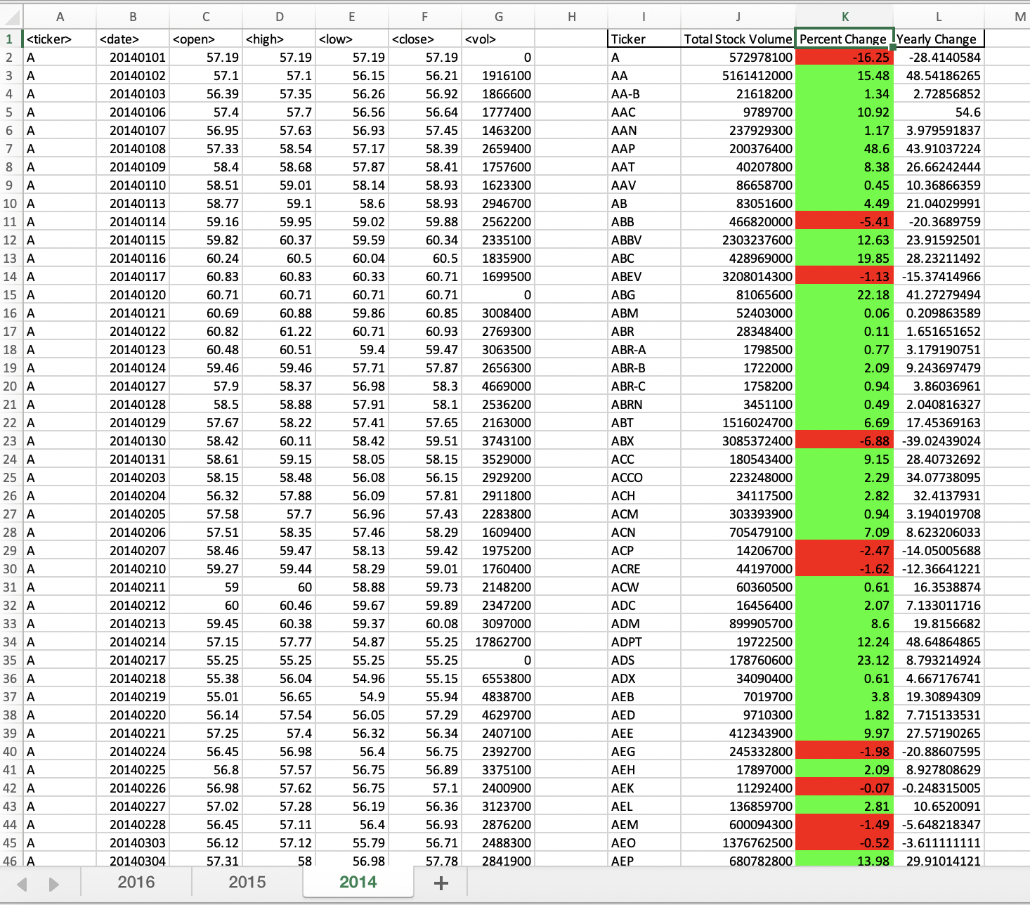

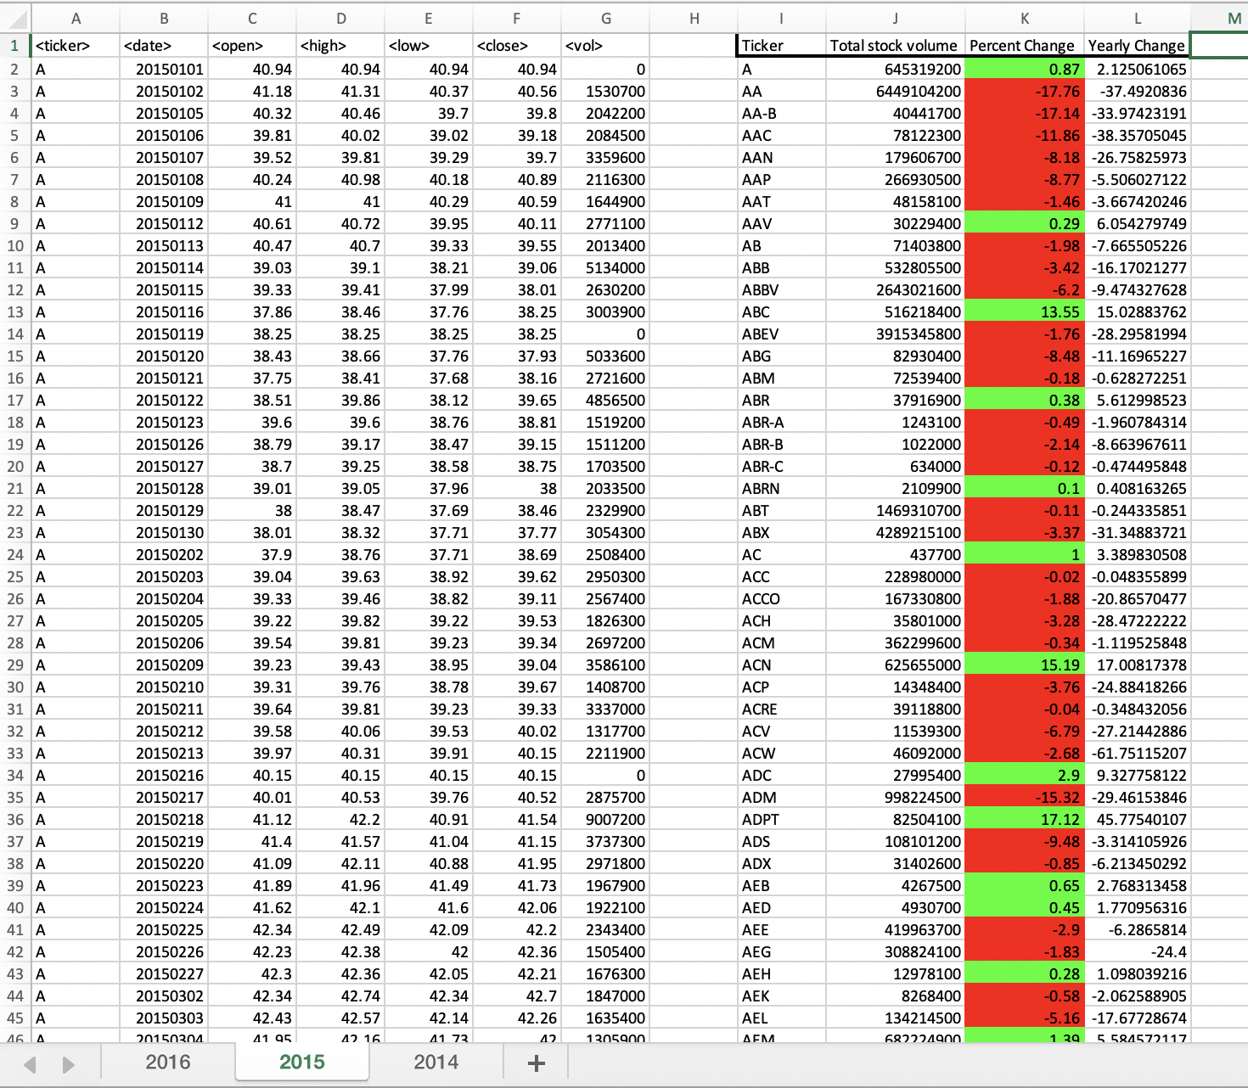

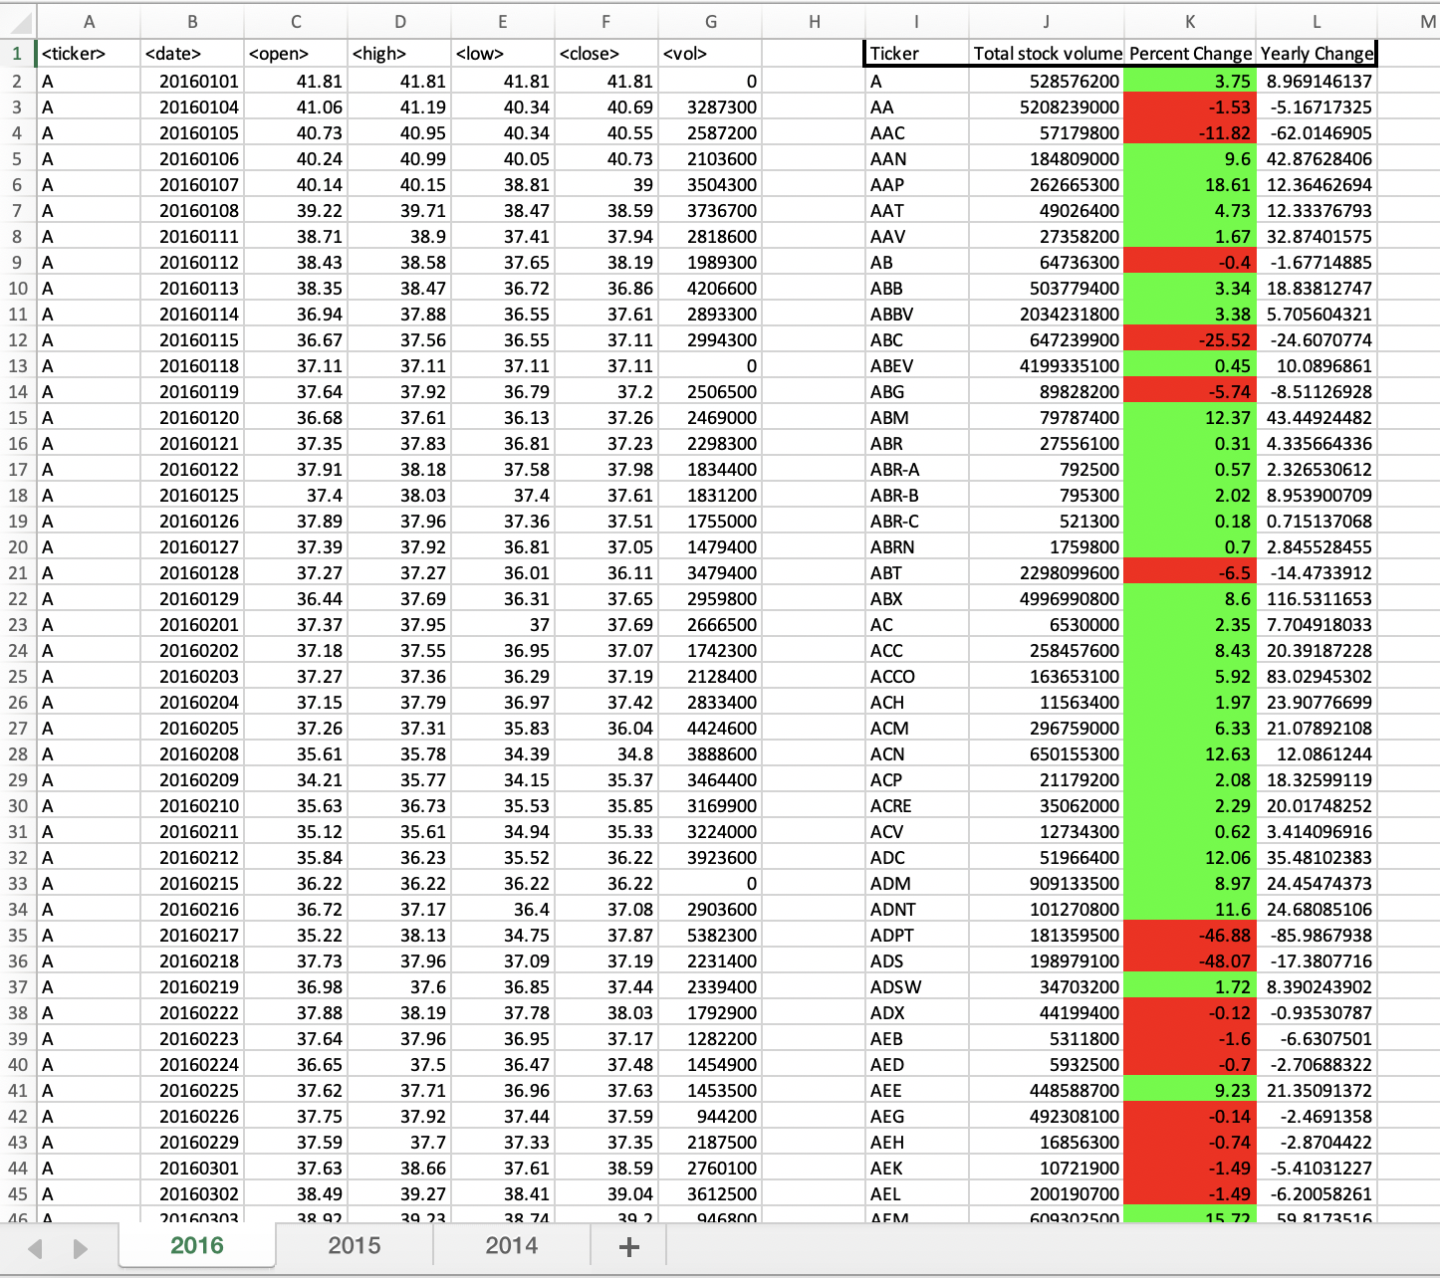

Sub tickertime()

'define variables

Dim ticker2 As Long

ticker2 = 2

LR = Cells(Rows.Count, 1).End(xlUp).Row

Dim total_volume As Double

total_volume = 0

Dim start As Long

start = 2

Dim percent As Double

'set values

For i = 2 To LR

total_volume = total_volume + Cells(i, 7).Value

'print values

If Cells(i + 1, 1).Value <> Cells(i, 1).Value Then

ticker = Cells(i, 1).Value

Cells(ticker2, 9).Value = ticker

Cells(ticker2, 10).Value = total_volume

'reseting to zero

total_volume = 0

ychange = Cells(i, 6) - Cells(start, 3).Value

If Cells(start, 3).Value > 0 Then

percent = 100 * ychange / Cells(start, 3).Value

Else

percent = 0

End If

If ychange > 0 Then

Cells(ticker2, 11).Interior.ColorIndex = 4

ElseIf ychange < 0 Then

Cells(ticker2, 11).Interior.ColorIndex = 3

Else

Cells(ticker2, 11).Interior.ColorIndex = 0

End If

start = i + 1

Cells(ticker2, 11).Value = ychange

Cells(ticker2, 12).Value = percent

ticker2 = ticker2 + 1

End If

Next i

End Sub